## 

**SOFTWARE REQUIREMENT SPECIFICATION**

**For**

**Stores Management Kandy MC**

*Version 1.3*

**Document Acceptance**

|  |  |
| --- | --- |
| Deliverable | Software Requirement Specification- Stores Management Service |
| Deliverable Date |  |
| Client | Kandy Municipal Council |

|  |  |  |  |
| --- | --- | --- | --- |
| Version | Date | Author | Reviewer |
| Version 1.1 | 18/11/2022 | M.M.H.R.Ruwanthi |  |
| Version 1.2 | 23/11/2022 | M.M.H.Ruwanthi |  |
| Version 1.3 | /03/2023 | M.M.H.Ruwanthi |  |

Document Amendment Register

Table of Contents

**1.** **ITEM MANAGEMENT** 5

**1.1.** **Add new Item** 5

**1.2.** **Search item (Search by code, Search by category)** 5

**1.3.** **Edit Item** 6

**1.4.** **Delete Item** 6

**1.5.** **View item history** 6

**1.6.** **View Current stock details.** 6

**2.** **OPENING STOCK** 7

**2.1.** **Add stock** 7

**2.2.** **Adjustment (Delete, Update)** 8

**2.3.** **Forward** 8

➢ **Current stock forward** 8

**3.** **GRN (GOOD RECEIVED NOTE)** 8

**3.1.** **Create GRN** 8

**3.2.** **Add to GRN** 9

**3.3.** **GRN overview** 10

**3.4.** **GRN search** 10

**3.5.** **Edit GRN** 10

**3.6.** **Delete Item form GRN** 10

**3.7.** **Print GRN** 10

**3.8.** **Calculate NBT/VAT** 10

**4.** **ISSUE RETURN** 11

**4.1.** **Return Issued Item** 11

**4.2.** **Search Return Details** 11

**5.** **PURCHASE MANAGEMENT** 11

**5.1.** **New purchase order** 11

**1.** **Create an Order** 11

**2.** **Need to Purchase** 12

**3.** **Low level** 12

**5.2.** **Search purchased order** 13

**5.3.** **Edit purchase order** 13

**6.** **SUPPLIER MANAGEMENT** 14

**6.1.** **New supplier** 14

**6.2.** **All suppliers** 15

**7.** **SUPPLIER RETURN** 16

**7.1.** **Supplier return** 16

**7.2.** **Return Overview** 16

**7.3.** **Search return** 16

**8.** **STOCK TRANSFER** 17

**8.1.** **Create Transfer** 17

**8.2.** **Search Transfer** 17

**8.3.** **Transfer details** 17

**9.** **STOCK ADJUSTMENT** 18

**9.1.** **Create a stock adjustment** 18

**9.2.** **Search stock adjustment** 19

**10.** **STOCK REPORTS** 19

**10.1** **VIEW OPENING STOCK IN EACH YEAR** 19

**10.2.** **VIEW RECEIVED STOCK BY CATEGORY** 20

**10.3.** **STOCK TRANSFER REPORT** 20

**10.4.** **SEARCH STOCK TRANSFER DETAILS REPORT** 20

**10.5.** **GET THE STOCK TRANSFER SUMMARY REPORT – EXPENSES LEDGER WISE.** 20

**10.6.** **BIN CARD** 21

➢ **View bin card** 21

➢ **Search bin card** 21

**10.7.** **STOCK LEDGER** 21

➢ **Search by Item Code** 21

➢ **Search by category** 21

# **ITEM MANAGEMENT**

## **Add new Item**

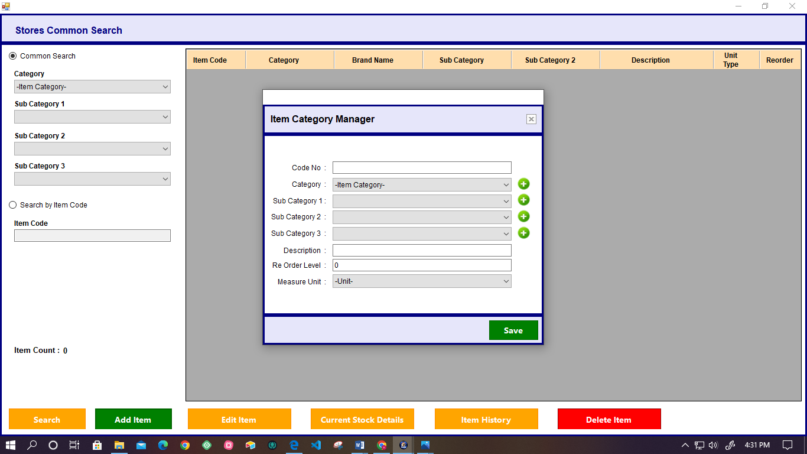

* User can new add item category with their subcategory using this interface.
* There is an options for save and clear the added details.
* This system facilitates to manage stores functionality. User can do following functionality by the using system.

## **Search item (Search by code, Search by category)**

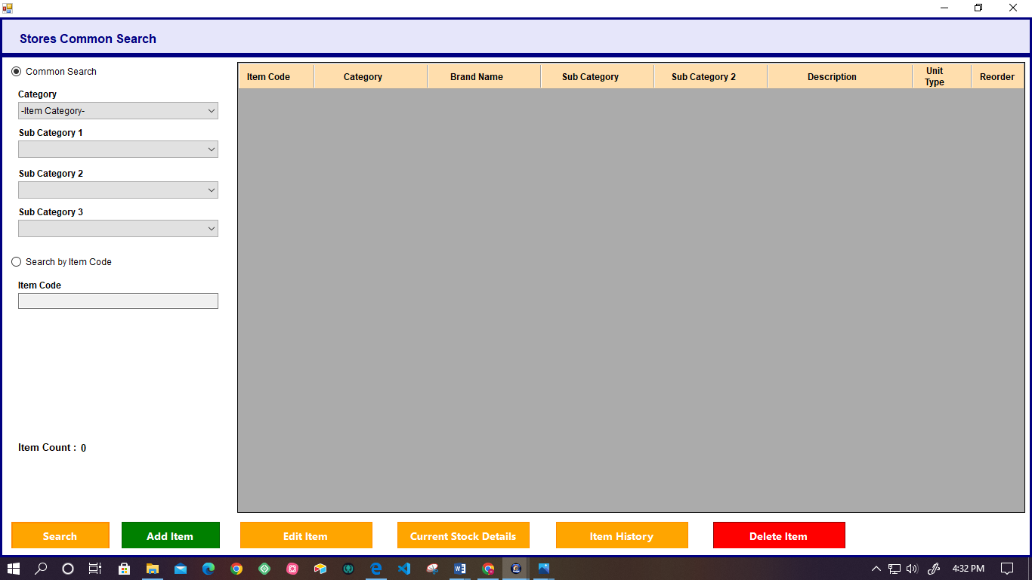

* The system facilitates the two options for the search item.

1. **Common search**

|  |  |  |
| --- | --- | --- |
| **Attribute** | **Field Type** | **Comment** |
| Category | Drop-down | Required |
| Sub Category 1 | Drop-down | Not Required |
| Sub Category 2 | Drop-down | Not Required |
| Sub Category 3 | Drop-down | Not Required |

1. **Search by item code**

|  |  |  |
| --- | --- | --- |
| **Attribute** | **Field Type** | **Comment** |
| Item Code | Text Field | Required |

* System automatically displays the item count in the user view.
* After selecting the particular item user can do the following functionality.

## **Edit Item**

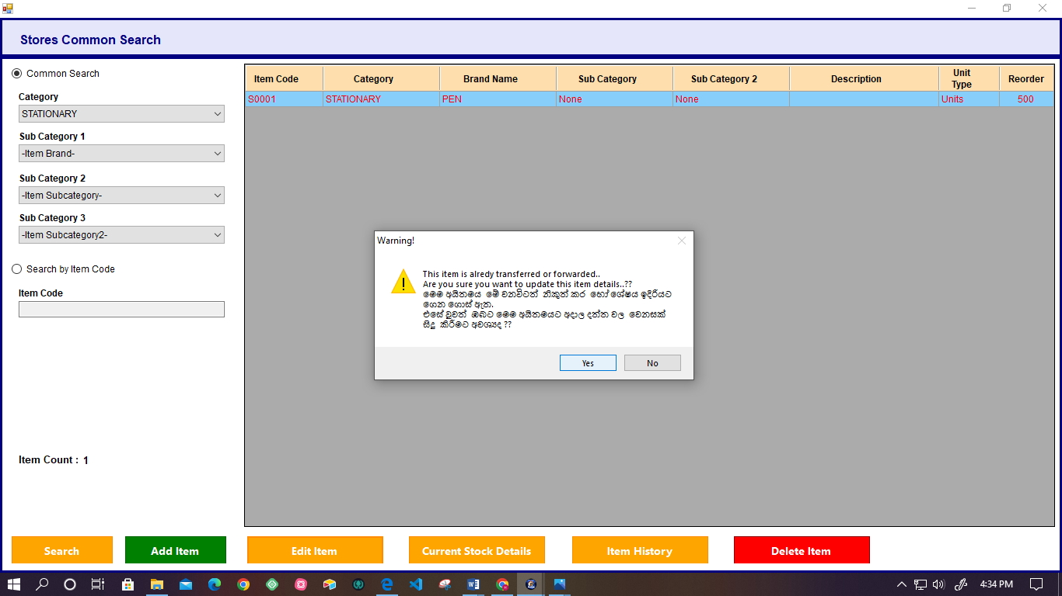

* This option for edit the already added item details.
* User can edit the item by clicking the “Edit Item” button.
* User can add or select the category and subcategory details.
* Also system facilitates the option for saving the details.

## **Delete Item**

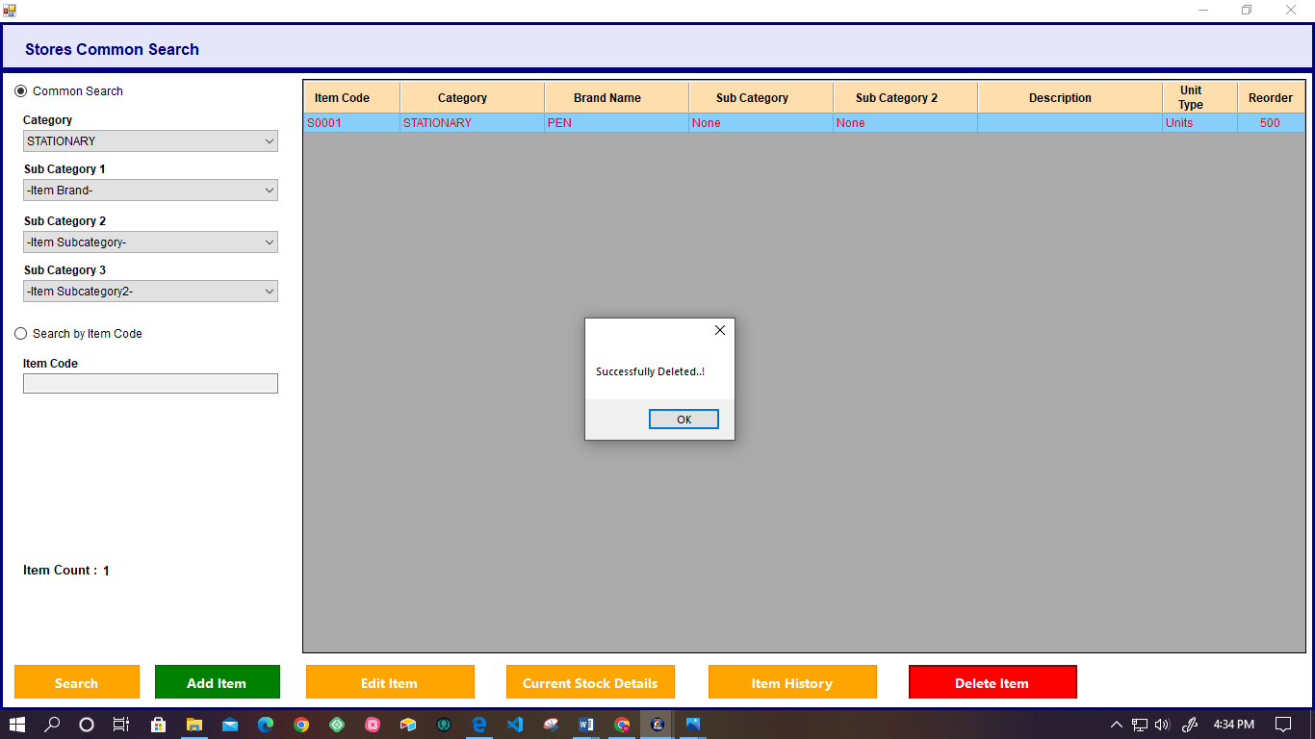

* System facilitates to user to delete the item using the “Delete Item” button.
* User has to select the item code and click delete button.
* But system not allows to delete the item, if item already transferred or forwarded.

## **View item history**

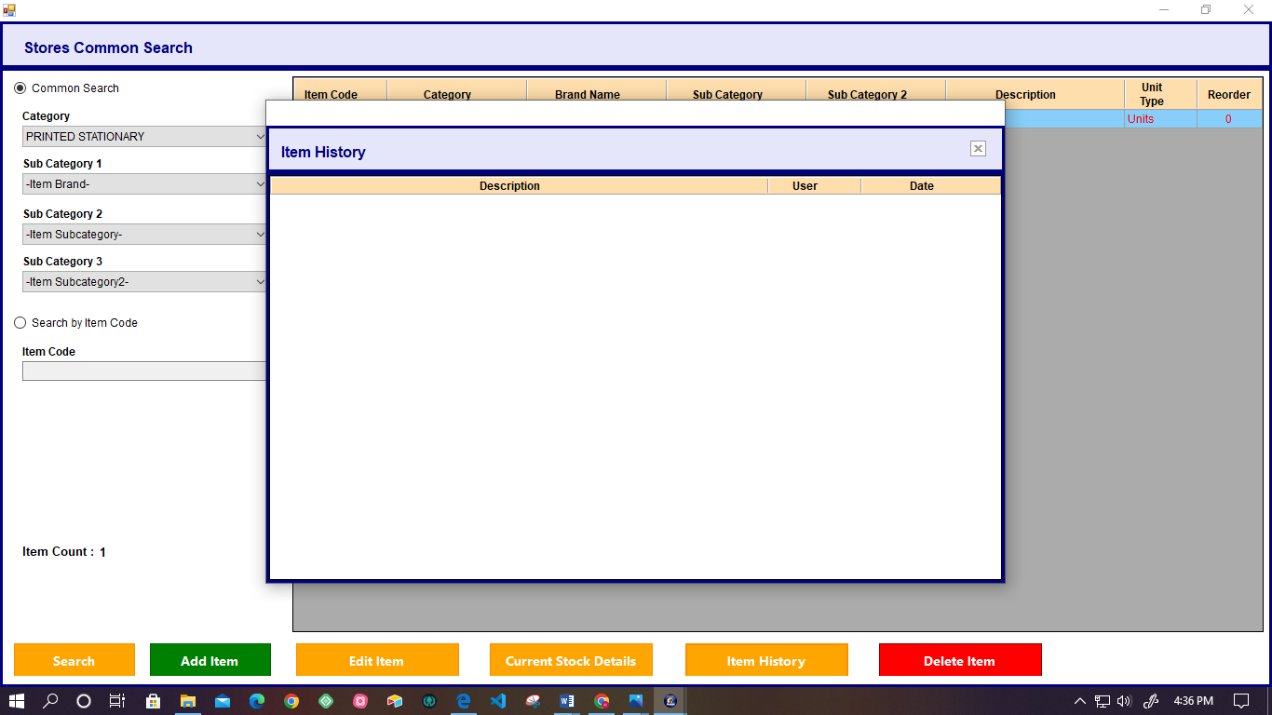

* System facilitates the user to view the history of the item.
* Display Description, User name, and Date and Time as an item history details.

## **View Current stock details.**

* User can view the current stock details by searching the item category (drop- down).
* System display the following details as current stock details.
* Code number
* Item Description
* Purchasing price
* Current stock
* Unit
* Total Value.
* System has facilitates to user to export details report as summary, Print as summary, Export, View and print options.

# **OPENING STOCK**

## **Add stock**

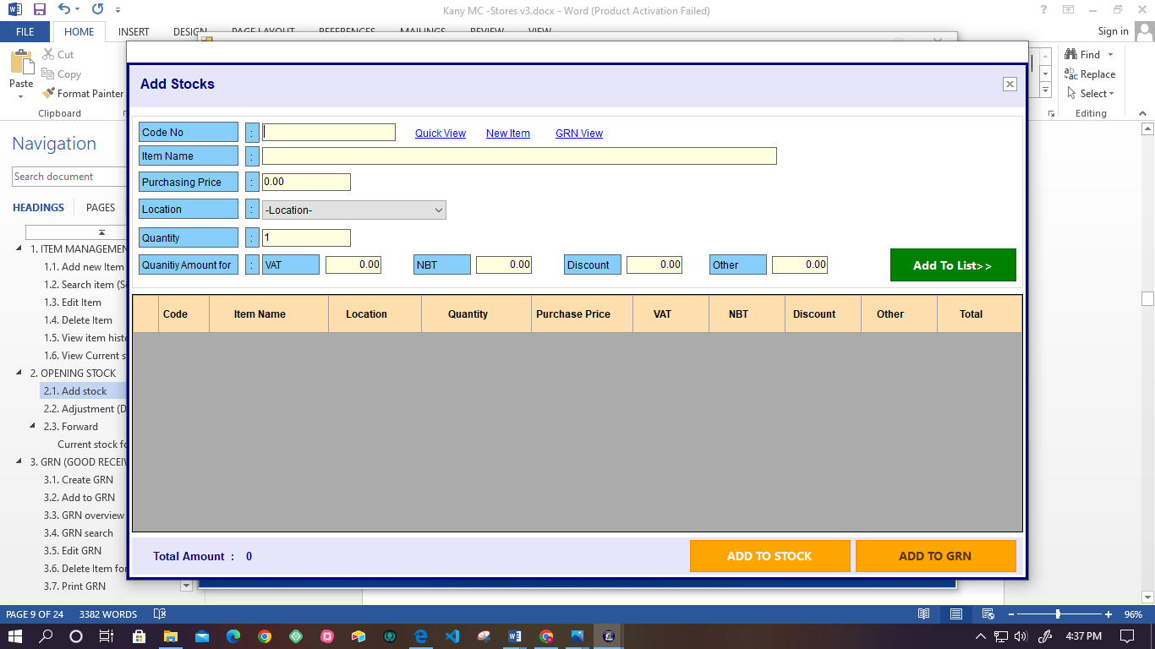

* After created the item category details system facilities to user to add item in to the stock.
* User has to enter the following details.

|  |  |  |
| --- | --- | --- |
| **Attribute** | **Field Type** | **Comment** |
| Code No | Text Field | Required |
| Item Name | Text Field | Required |
| Purchasing Price | Text Field | Not Required |
| Location | Drop-down | Required |
| Quantity | Text Field | Not Required |
| **Quantity Amount** | | |
| VAT | Text Field | Not Required |
| NBT | Text Field | Not Required |
| Discount | Text Field | Not Required |
| Other | Text Field | Not Required |

* After entering the details, the user can add item details to the list.
* System calculates the total amount and displays it.
* If the users don’t want to add that item to the stock, they can remove it.
* System facilitates the option to add to stock.
* In this time add to GRN option is disable.
* Also, the system provides the following functionality.
* **Quick view**

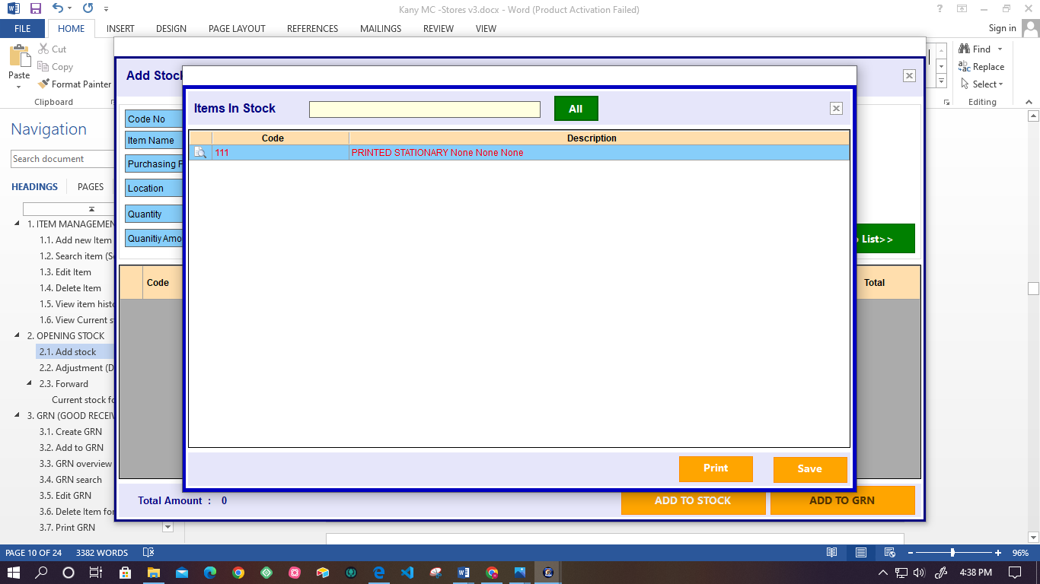

* System facilities to user to search the item details quickly by searching the item code or related word.
* Also if there is a changes of the item category details user can edit the item category details through the quick view and save.
* User can print and save the item list.
* **New Item**

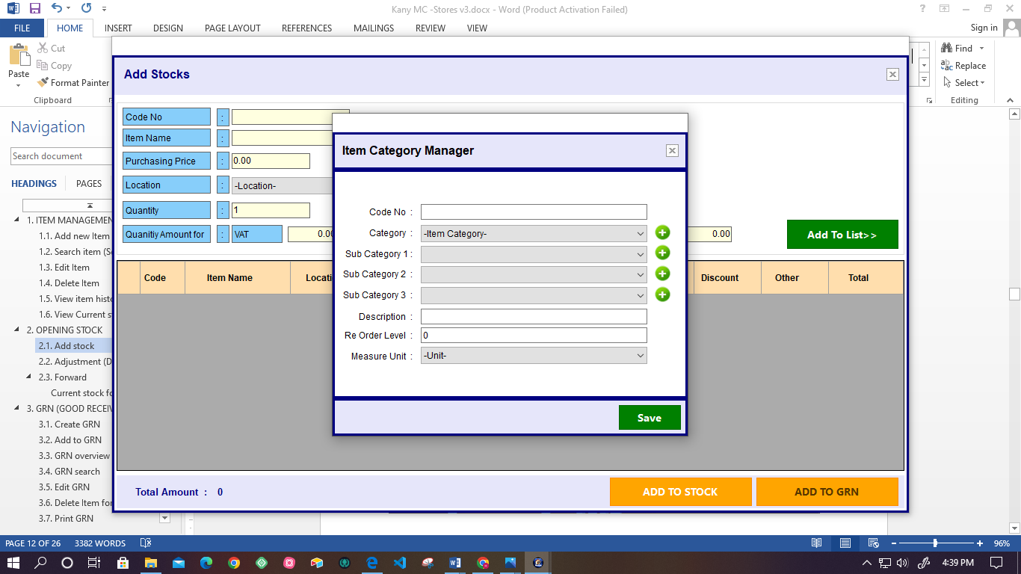

* If the user does not add the item to the system before adding it to the stock, the user can click the new item link and add the new category item to the system. (add list)
* **GRN View *(Refer :3.1)\***

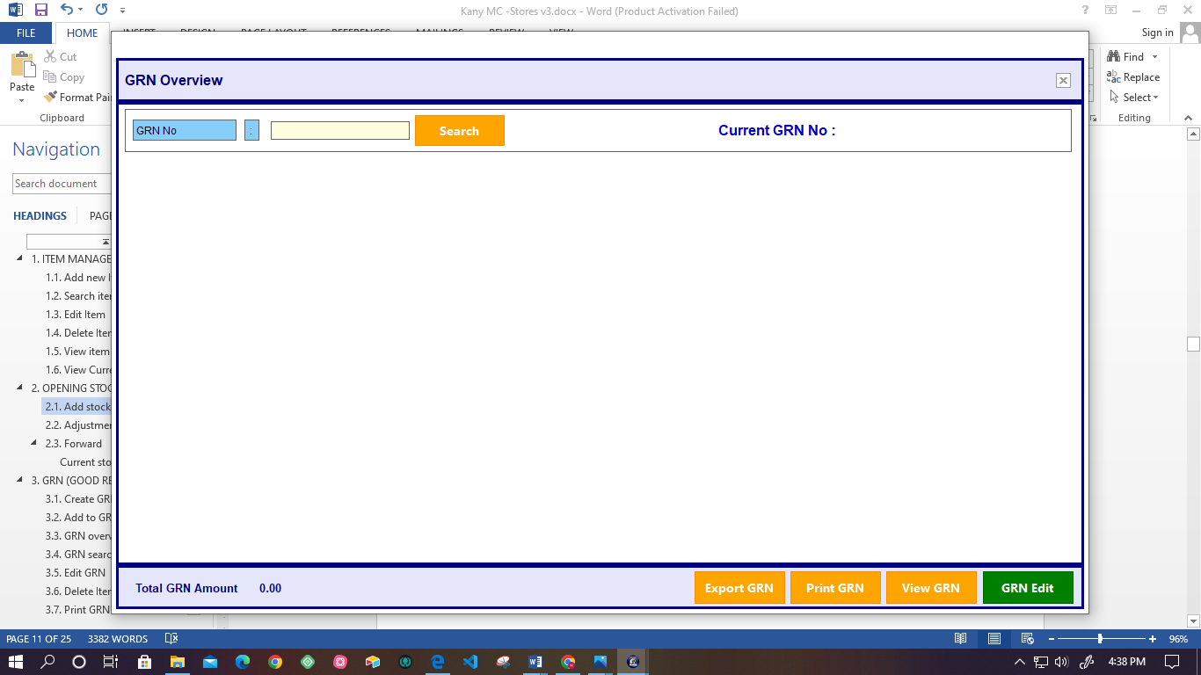

* User can view the GRN details by searching the GRN Number.
* Then system calculates and displays the total GRN amount.
* Also system facilitates the GRN print, view, export, and edit GRN.

## **Adjustment (Delete, Update)**

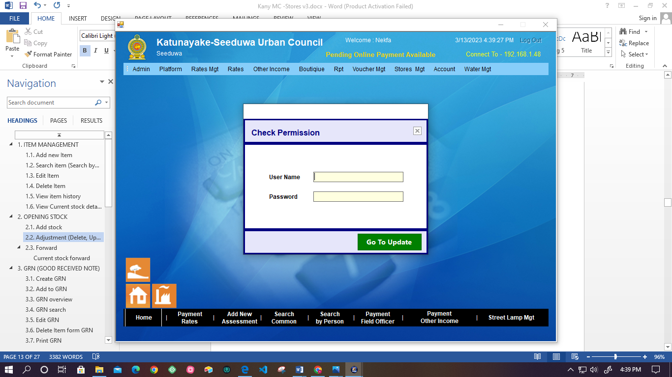

* System facilitates the user to adjustment of the opening stocks.
* User has to enter the following details to get permission.

|  |  |  |
| --- | --- | --- |
| **Attribute** | **Field Type** | **Comment** |
| User name | Text Field | Required |
| Password | Text Field | Required |

* Then, the user can direct to the adjustment of the opening stocks.
* User can do the following functionality.
* **Delete Opening stock**

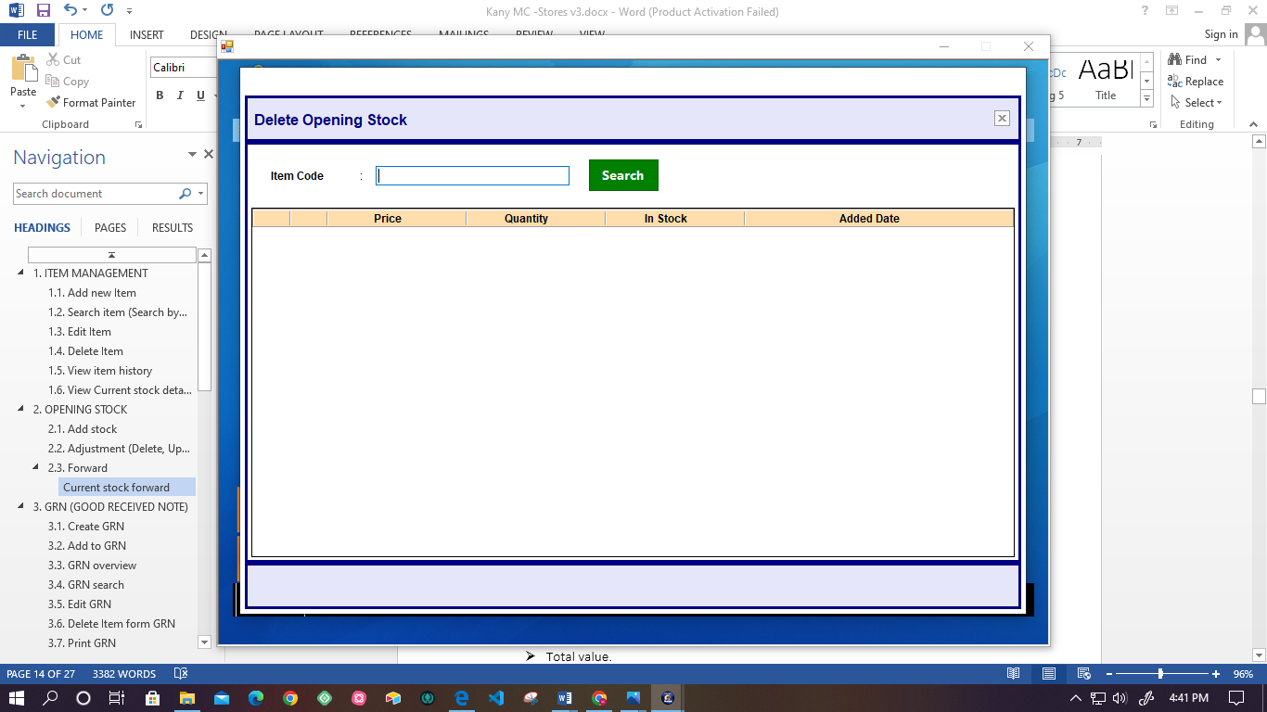

* **Update Opening stock**
* User can update the following details.
* Code Number
* Item Name
* Location
* Purchasing price
* Quantity

## **Forward**

### **Current stock forward**

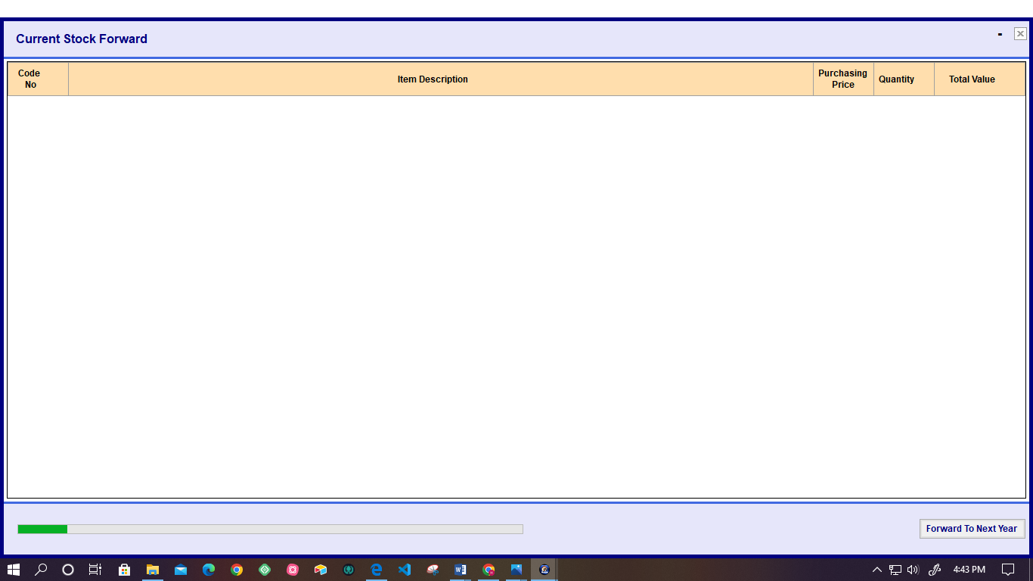

* System facilitates the user to forward the current stock to the Next year.
* System displays the following details.
* Code Number
* Item Description
* Purchasing price
* Quantity
* Total value.
* System automatically calculates the Current Total Stock Value.
* Also user can select the year of current forward stock using the drop-down menu.

# **GRN (GOOD RECEIVED NOTE)**

## **Create GRN**

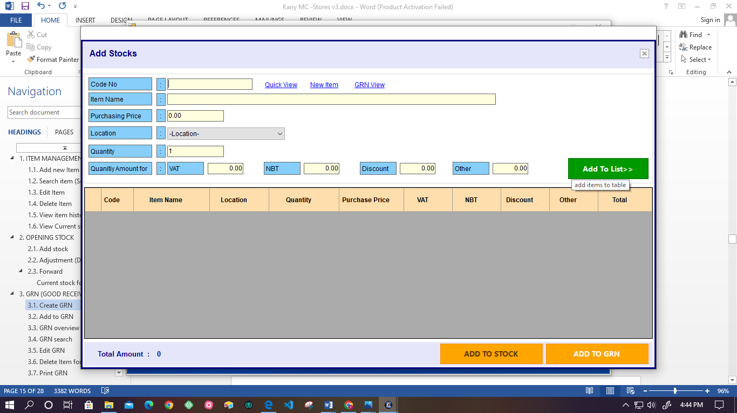

* After added the item details in to the list user can add the GRN details to the system.
* User has to enter the following item details for the add stock.

|  |  |  |
| --- | --- | --- |
| **Attribute** | **Field Type** | **Comment** |
| Code No | Text Field | Required |
| Item Name | Text Field | Required |
| Purchasing Price | Text Field | Not Required |
| Location | Drop-down | Required |
| Quantity | Text Field | Not Required |
| **Quantity Amount** | | |
| VAT | Text Field | Not Required |
| NBT | Text Field | Not Required |
| Discount | Text Field | Not Required |
| Other | Text Field | Not Required |

* System automatically calculates the purchasing price, quantity, and Quantity Amount (VAT, NBT, Discount, Other), then displays the Total Amount.
* If a user wants to delete the added item details, who can remove them from the list.

## **Add to GRN**

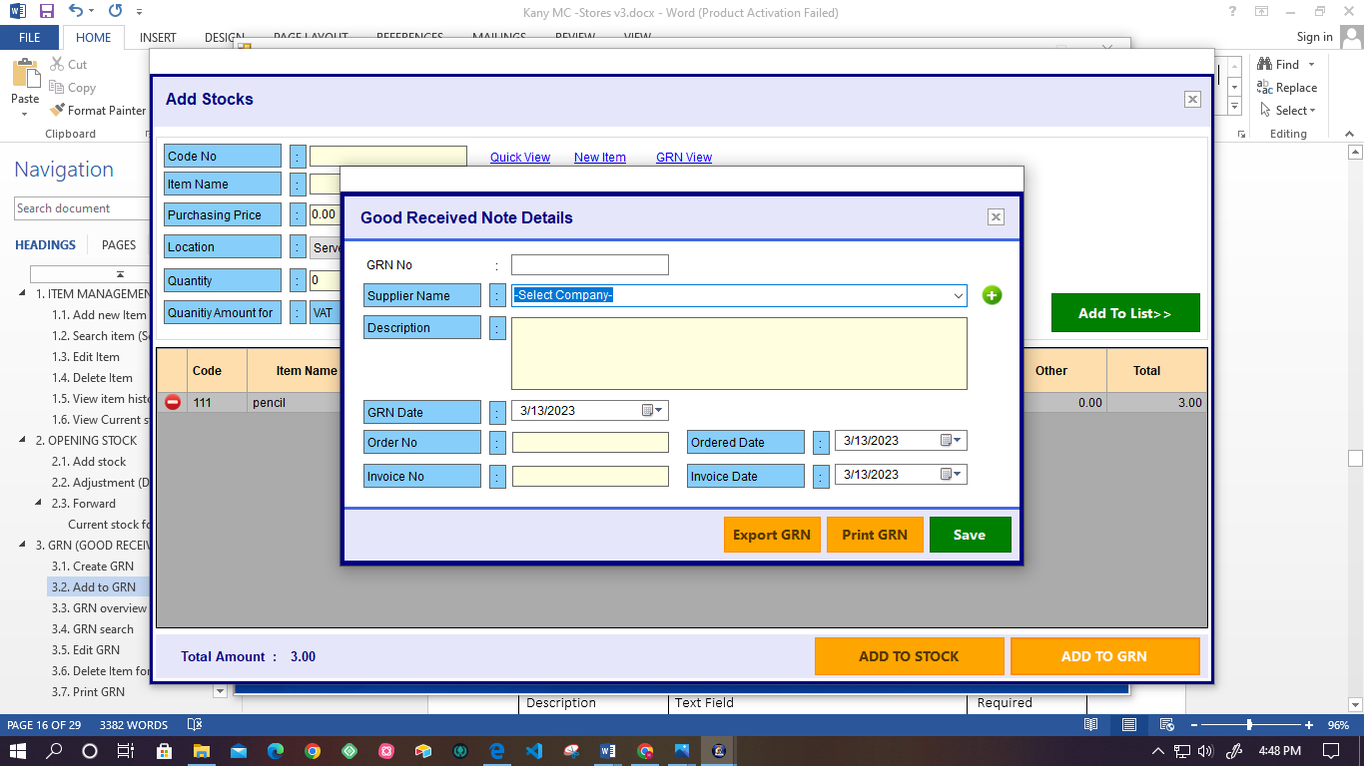

* After the user creates the item list, the user can add it to GRN.

In this time Add to stock option is disable. (***Refer: 2.1***)

* Then, the user has to enter the Good Receive Note Details.
* Following details have to enter into the GRN.

|  |  |  |
| --- | --- | --- |
| **Attribute** | **Field Type** | **Comment** |
| GRN Number | Text Field | Required |
| Supplier Name | * Drop-down(If already exists) * Click “+” icon (for add new supplier (***refer: 6.1***) | Required |
| Description | Text Field | Required |
| GRN Date | Calendar | Required |
| Order Number | Text Field | Required |
| Invoice Number | Text Field | Required |
| Ordered date | Calendar | Required |
| Invoice Date | Calendar | Required |

* System facilitates the Export, Print, and Save of the GRN.

## **GRN overview**

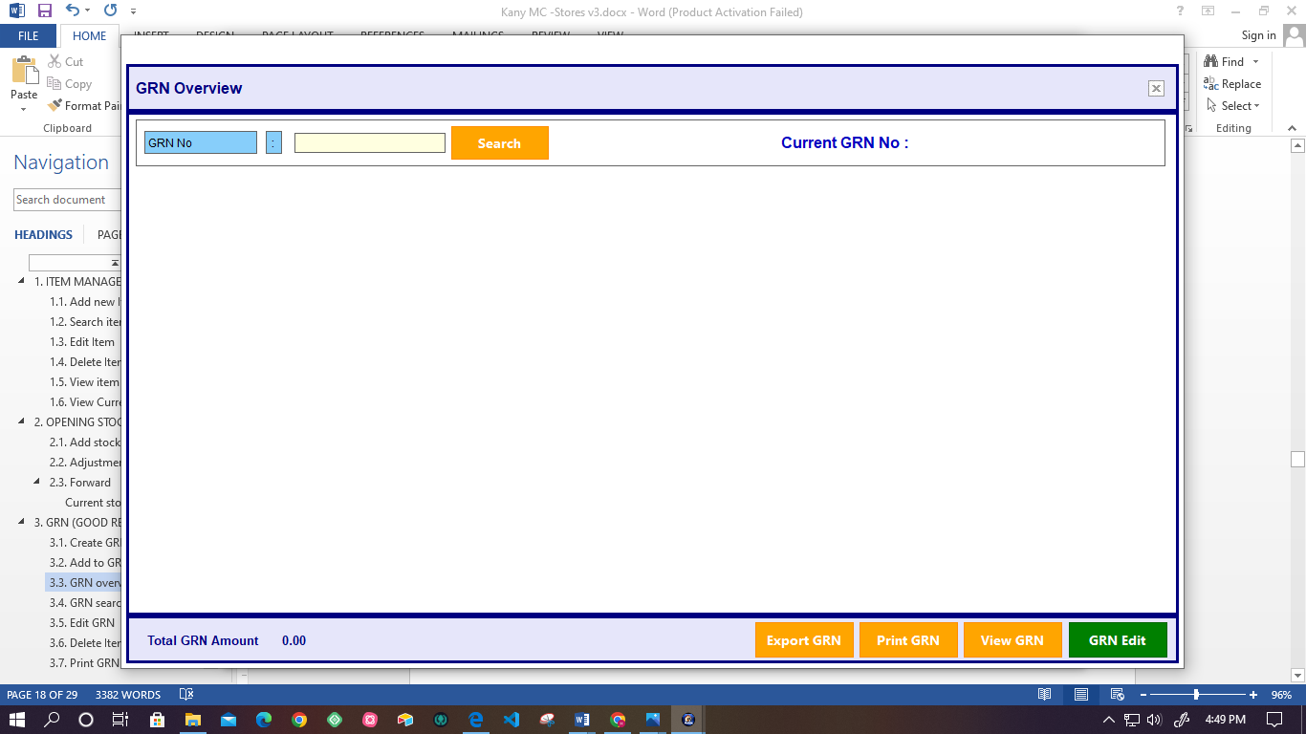

* User can search the already added GRN details by searching the GRN Number.
* Also system automatically displays the Total GRN Amount.
* User can edit and delete the already added item of GRN details.
* System facilitates users to export, print, view, and edit the GRN.

## **GRN search**

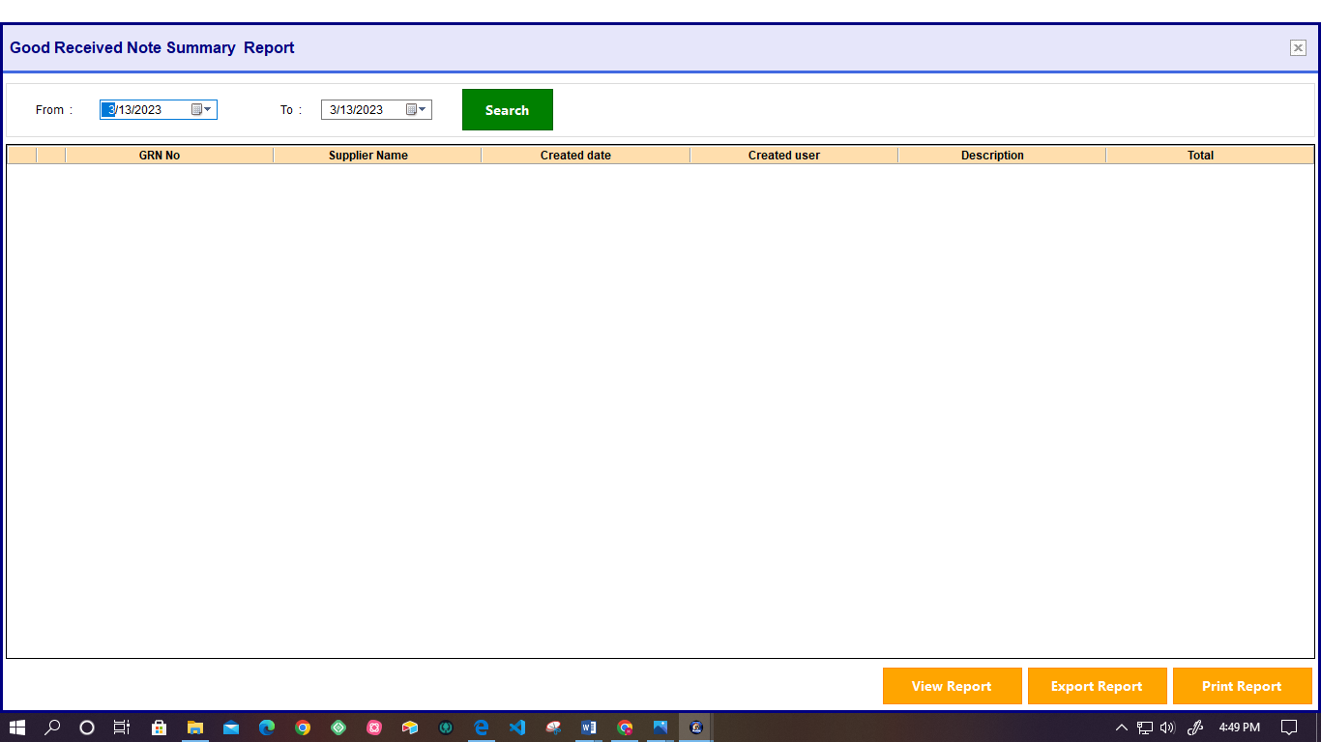

* User can get the Good Received Note Summary Report by searching the date duration.
* Following details are displayed in the summary report.
* GRN Number
* Supplier Name
* Created Date
* Created User
* Description
* Total
* Also System facilitates users to Export, View, and Print the GRN Summary Report.

## **Edit GRN**

* System facilitates to user to edit the added GRN details and save the changes details.

## **Delete Item form GRN**

* System facilitates to user to delete the Item from GRN.

## **Print GRN**

* System facilitates users to print the GRN report with details as document file.

## **Calculate NBT/VAT**

* After user enter the NBT and VAT values system automatically calculate the Total GRN amount.

# **ISSUE RETURN**

## **Return Issued Item**

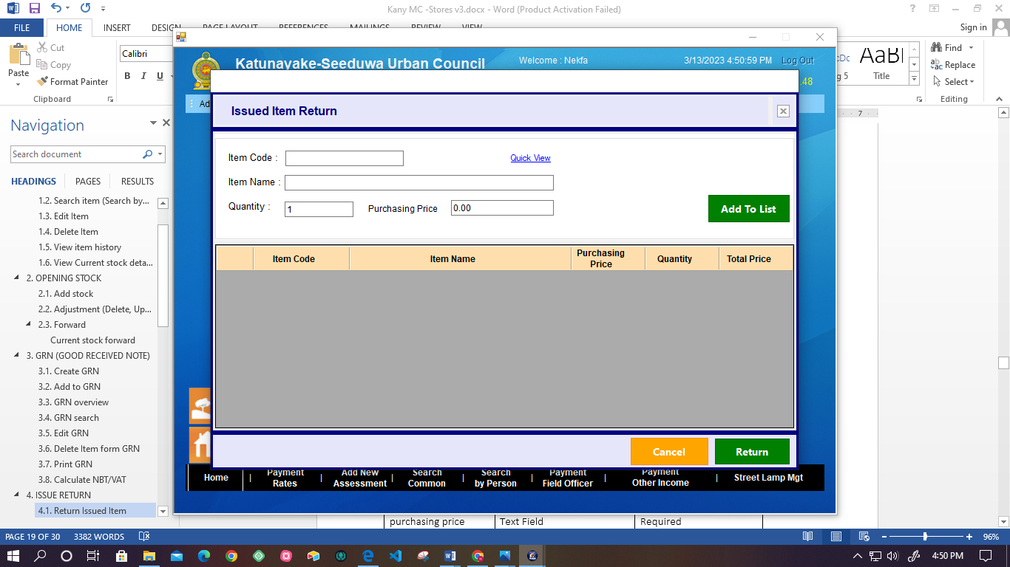

* + - * The system facilitates recording to issue item returns.
      * The user must enter the following details.

|  |  |  |
| --- | --- | --- |
| **Attribute** | **Field Type** | **Comment** |
| Item code | Text Field | Required |
| Item name | Text Field | Required |
| Quantity | Text Field | Required |
| purchasing price | Text Field | Required |

* + - * Then, the user can add that details to the list.
      * The list displays the following details with the total price.
* Item code
* Item name
* Quantity
* Purchasing price.
  + - * Then, the user can return the item.

## **Search Return Details**

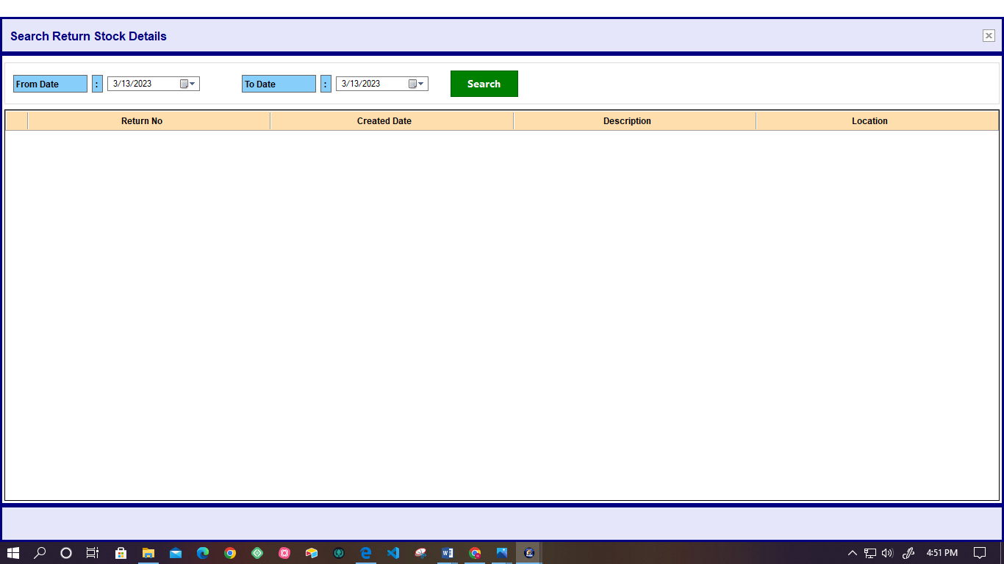

* System facilitates the user to get the Return stock Details by searching the particular time period.
* Following details are displayed by the system.
* Return Number
* Location
* Created Date
* Description

# **PURCHASE MANAGEMENT**

## **New purchase order**

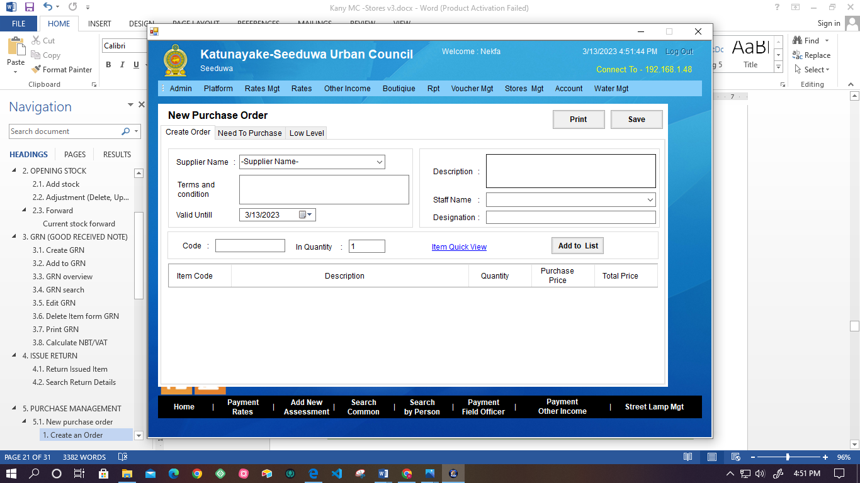

* + - * There is a three section for the purchase the order.

### **Create an Order**

To purchase an order user has to create an order.

To generate the order, user has to enter the following details.

|  |  |  |
| --- | --- | --- |
| **Attribute** | **Field Type** | **Comment** |
| Supplier Name | Drop-down | Required |
| Terms and Conditions | Text Field | Not Required |
| Valid Date | Calendar | Required |
| Description | Text Field | Not Required |
| Staff Name | Drop-down | Required |
| Designation | Text Field | Not Required |
| Code | Text Field | Required |
| In Quantity | Text Field | Required |

* The system facilitates the addition of details to the list.
* Following details are display in the details list.
* Item code
* Description
* Quantity
* Purchase Price
* Total Price

### **Need to Purchase**

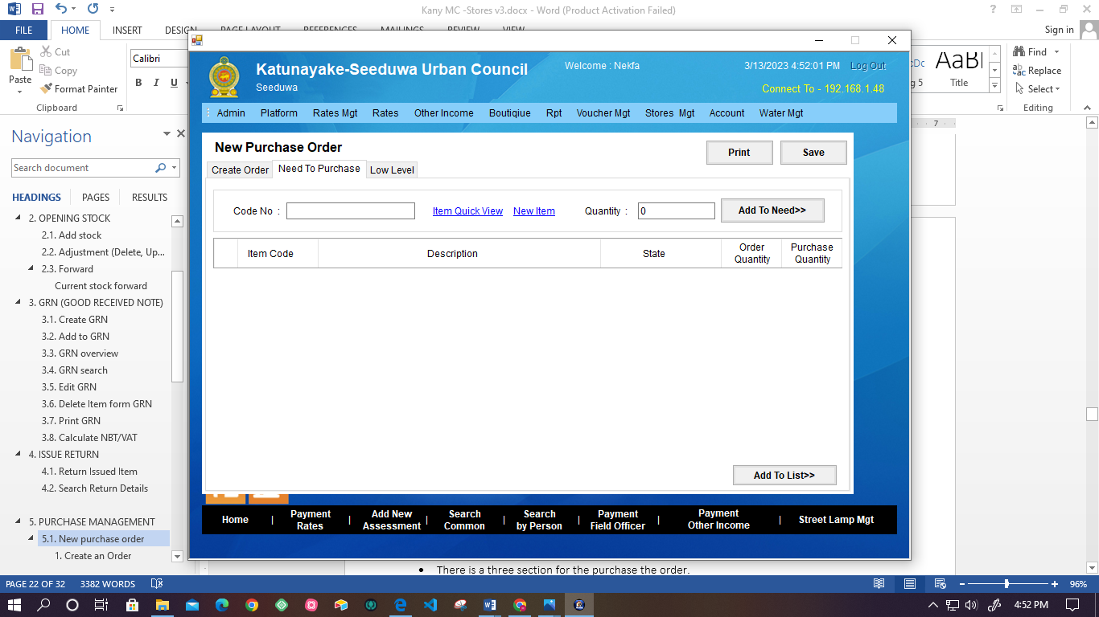

* If the user needs to purchase an item, user has to enter the following details.

|  |  |  |
| --- | --- | --- |
| **Attribute** | **Field Type** | **Comment** |
| Code | Text Field | Required |
| In Quantity | Text Field | Required |

* After adding the item as need to purchase following details are displayed in the list.
* Item Code
* Description
* State
* Order Quantity
* Purchase Quantity
* Also there is an options of item quick view and, New Item.

### **Low level**

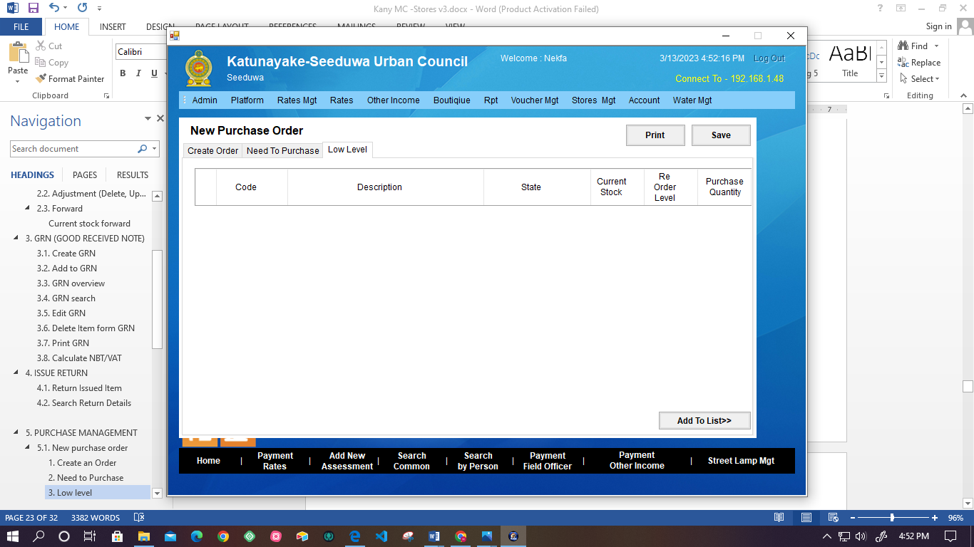

* User can add the already added item in to purchase list.
* User has to select the item in the list.
* System displays the following details of the item.
* Code
* Description
* State
* Current Stock
* Re order Level
* Purchase Quantity
* There is an option the Print and save the purchased item list details.

## **Search purchased order**

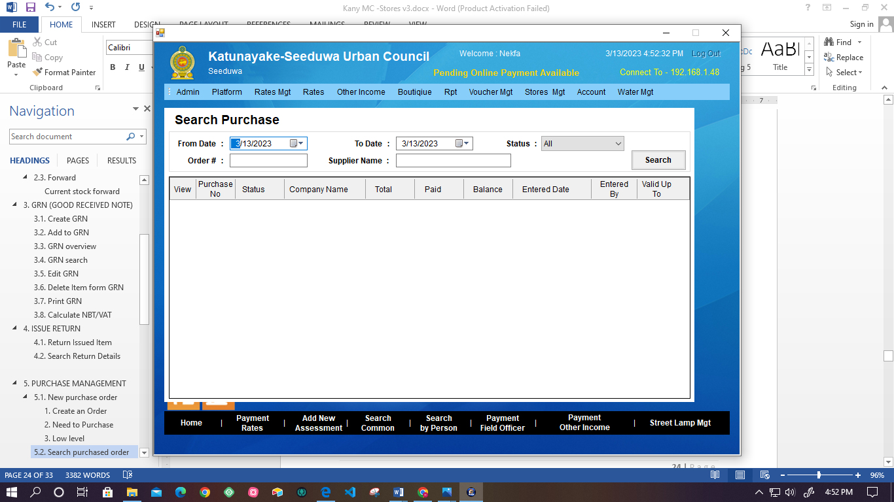

* The system facilitates the user to search the purchased item details list.
* User can search the purchased order using the following options.

|  |  |  |
| --- | --- | --- |
| **Attribute** | **Field Type** | **Comment** |
| From Date | Calendar |  |
| To Date | Calendar |  |
| Status | Drop-down | Select Options:   * All * Pending * Received * Reject * Cancel |
| Order | Text Field |  |
| Supplier Name | Text Field |  |

## **Edit purchase order**

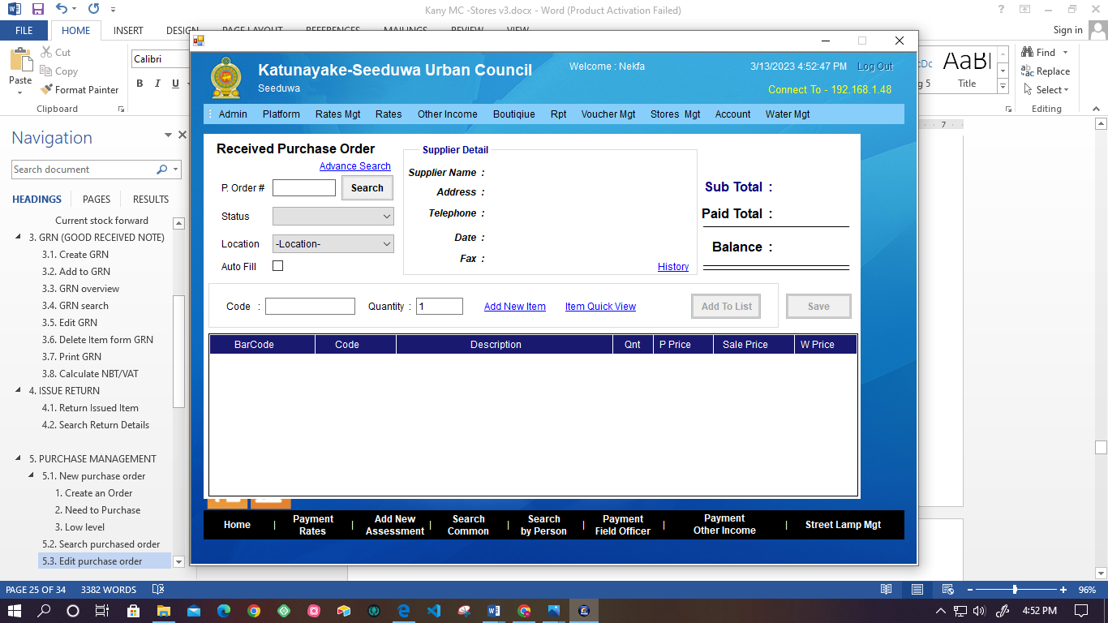

* After user purchased the order, if there is any changes user can edit the purchase order.
* To get the order details user has to enter the following details.

|  |  |  |
| --- | --- | --- |
| **Attribute** | **Field Type** | **Comment** |
| P-Order # | Text Field | Required |
| Status | Drop-down | Select Options:   * All * Pending * Received * Reject * Cancel |
| Location | Drop-down | Not Required |
| Supplier Name | Check box | Not Required |

* After user searched the order details system display the supplier details.
* Supplier Name
* Address
* Telephone
* Date
* Fax
* System display the following details of the order.
* Sub Total
* Paid Total
* Balance
* For edit the order user has to enter following details.

|  |  |  |
| --- | --- | --- |
| **Attribute** | **Field Type** | **Comment** |
| Code | Text Field | Required |
| In Quantity | Text Field | Required |

* Then adding after the details user can view the following details form the list.
* Supplier Name
* Code
* Description
* Qnt
* P Price
* Sale Price
* W price

# **SUPPLIER MANAGEMENT**

## **New supplier**

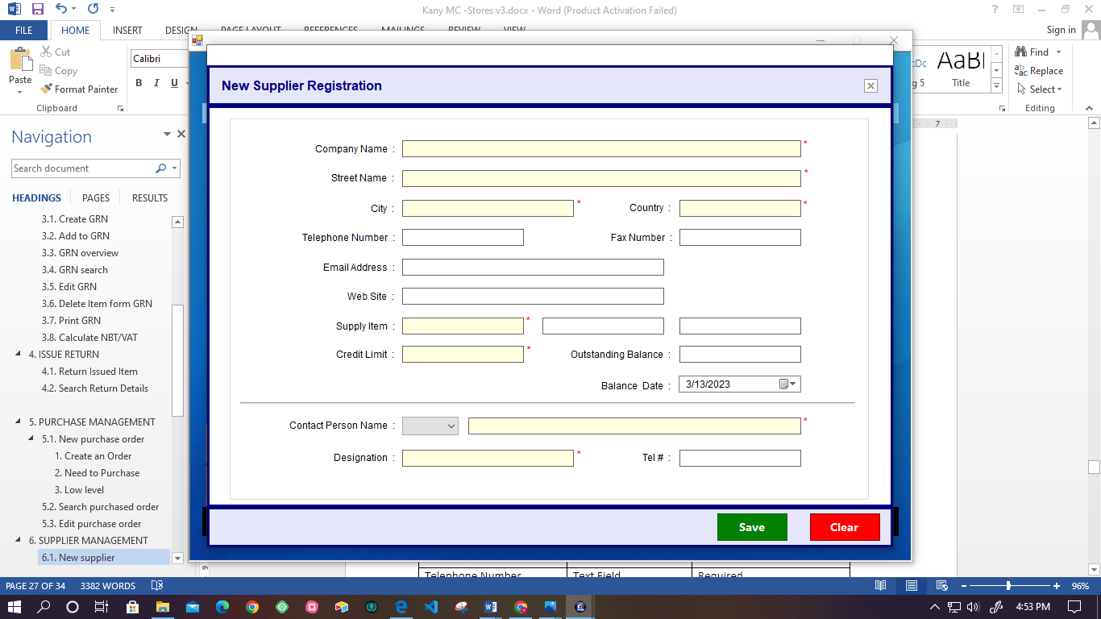

* System facilitates to register new supplier.
* Following details are required for registration.

|  |  |  |
| --- | --- | --- |
| **Attribute** | **Field Type** | **Comment** |
| Company Name | Text Field | Required |
| Street Name | Text Field | Required |
| City | Text Field | Required |
| Country | Text Field | Required |
| Supply item | Text Field | Required |
| Credit Limit | Text Field | Required |
| Telephone Number | Text Field | Required |
| Fax Number | Text Field | Required |
| Email Address | Text Field | Not Required |
| Web site | Text Field | Not Required |
| Outstanding Balance | Text Field | Not Required |
| Balance Date | Calendar | Not Required |
| Contract person Name | Drop down(person title)/Text Field | Required |
| Designation | Text Field | Required |
| Tel # | Text Field | Not Required |

* Also system facilitates the save or clear the filled register application.

## **All suppliers**

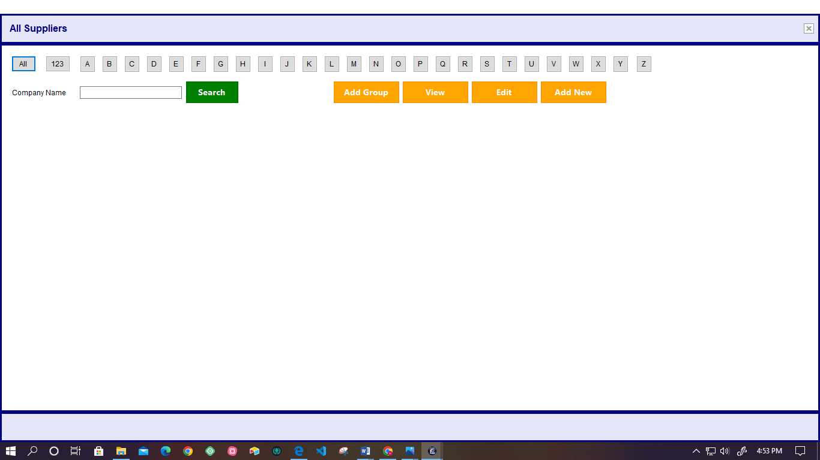

* System facilitates to user to search the supplier details by option of All, alphabetic letters, Numeric and Company Name.
* Also system facilitates the following functionalities.
* Add group
* View each suppliers details
* Edit supplier details
* Add new supplier
* Following details are displays the list of supplier.
* Company Name
* Contact Person
* Telephone Number
* Supply Items
* Designation
* Credit Period.

# **SUPPLIER RETURN**

## **Supplier return**

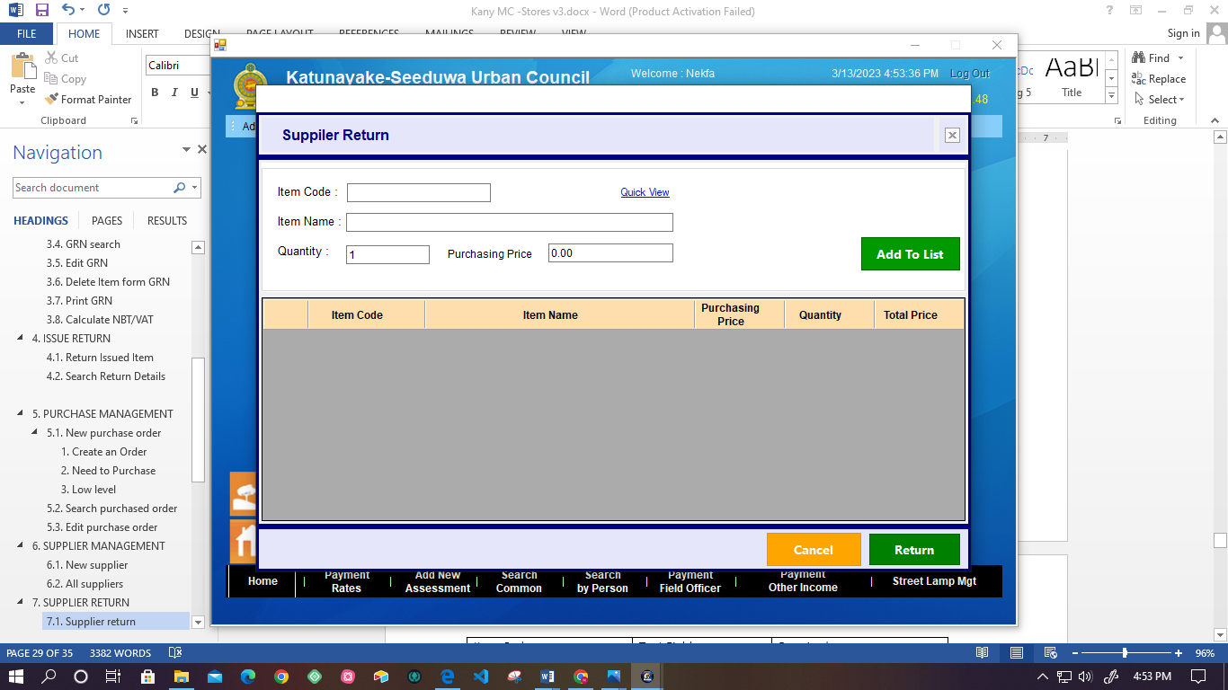

* System facilitates to record the details of supplier return details.
* User has to enter the following details.

|  |  |  |
| --- | --- | --- |
| **Attribute** | **Field Type** | **Comment** |
| Item Code | Text Field | Required |
| Item Name | Text Field | Required |
| Quantity | Text Field | Required |
| Purchasing price | Text Field | Required |

* After being added to the list user can return the supplier.
* Following details are display in the return list.
* Item Code
* Item Name
* Purchasing price
* Quantity
* Total price

## **Return Overview**

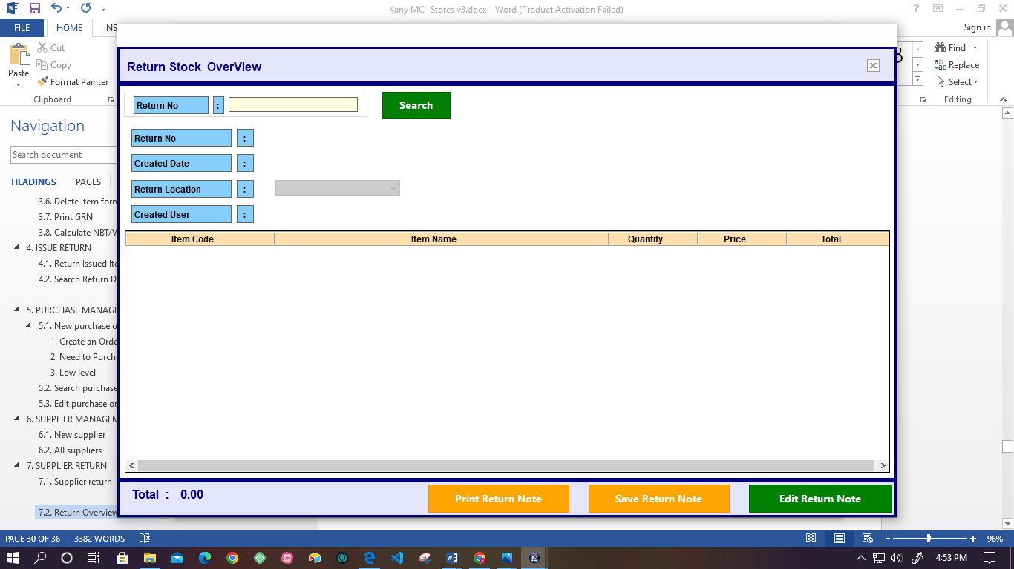

* System facilitates the user to view the return stock overview.
* When the user enters the Return Number in to the system automatically displays the following details.
* Return Number
* Created date
* Return Location
* Created User
* Following list details are displayed after searching the Return Number.
* Item Code
* Item name
* Quantity
* Price
* Total
* Also user can Print, Save, and Edit the Return Note.

## **Search return**

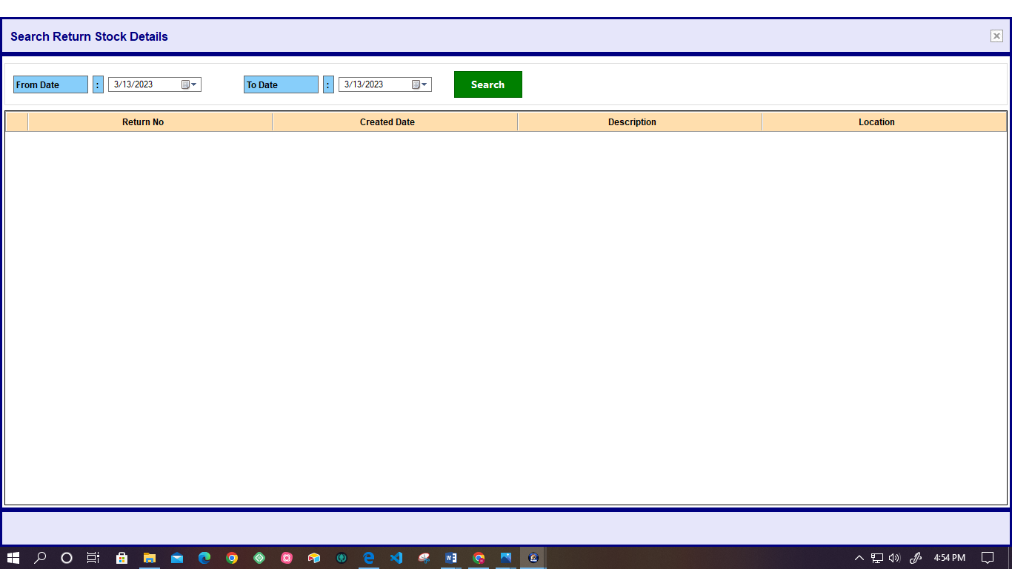

* System facilitates the user to get the stock return details by searching the particular date period.
* The system views the following details.
  + - Return Number
    - Created Date
    - Description
    - Location

# **STOCK TRANSFER**

## **Create Transfer**

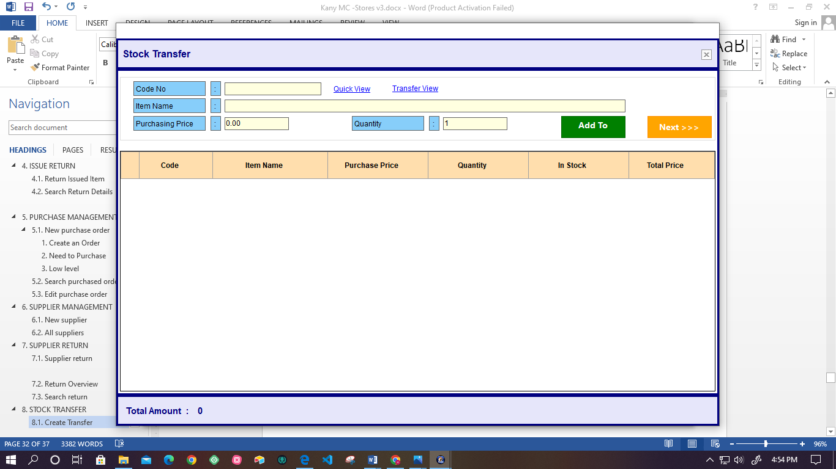

* System facilitates the item stock transfer.
* When the user input the item code system automatically displays the item name.

|  |  |  |
| --- | --- | --- |
| **Attribute** | **Field Type** | **Comment** |
| Code No | Text Field | Required |
| Item Name | Text Field | Not Required |
| Quantity | Text Field | Required |
| Purchasing price | Text Field | Required |

* According to the related item, system add the details in to the list.
* Code
* Item Name
* Purchasing price
* Quantity
* In stock
* Total price
* System automatically displays the total amount of the stock.

## **Search Transfer**

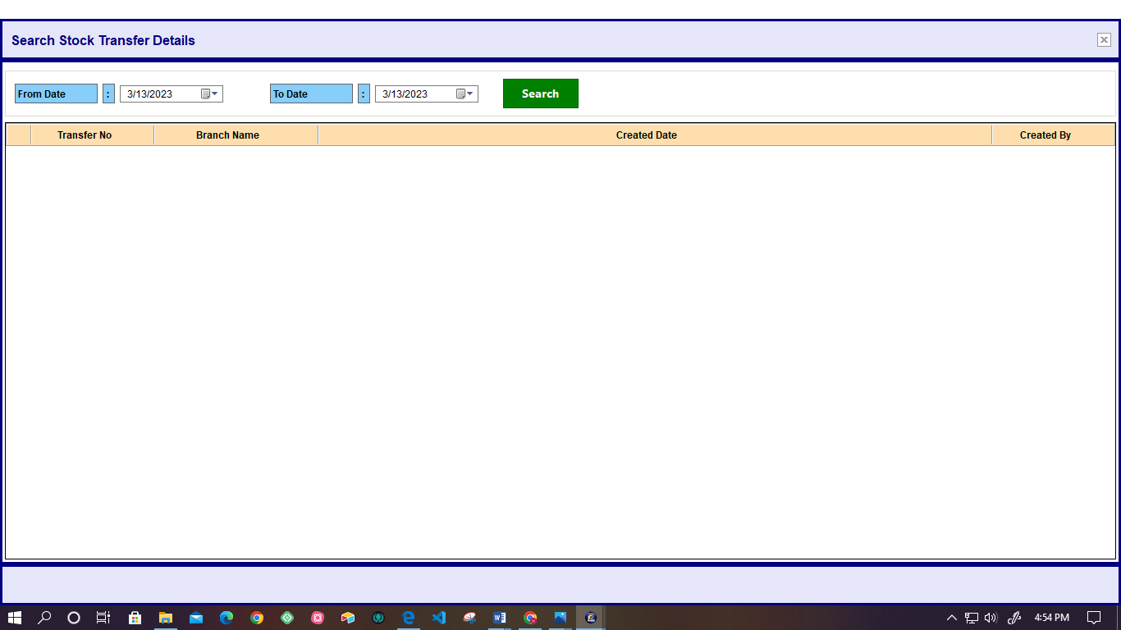

* System allows users to get the Stock Transfer Details by searching the particular time period.
* Following details are displayed by the system.
* Transfer Number
* Branch Name
* Created Date
* Created By

## **Transfer details**

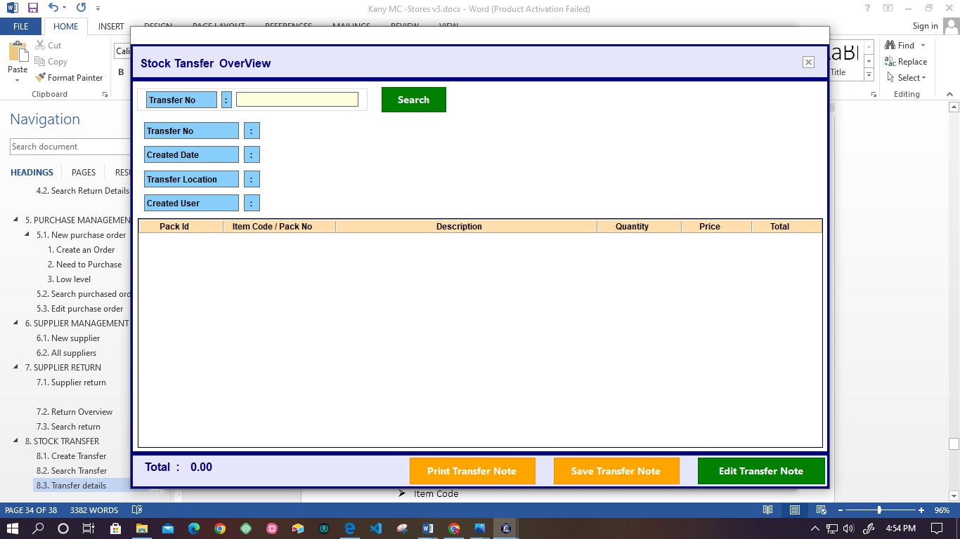

* User can view the transferred details by searching the transfer Number.
* After user enter the transfer Number, system automatically displays following details.
* Transfer Number
* Created Date,
* Transfer Location
* Created User
* According to the transfer number transferred, the system displays the list details.
* Packed Id
* Item Code
* Description
* Quantity
* Price
* Total
* Also, there is a functionality to Print, Save and edit transfer notes.

# **STOCK ADJUSTMENT**

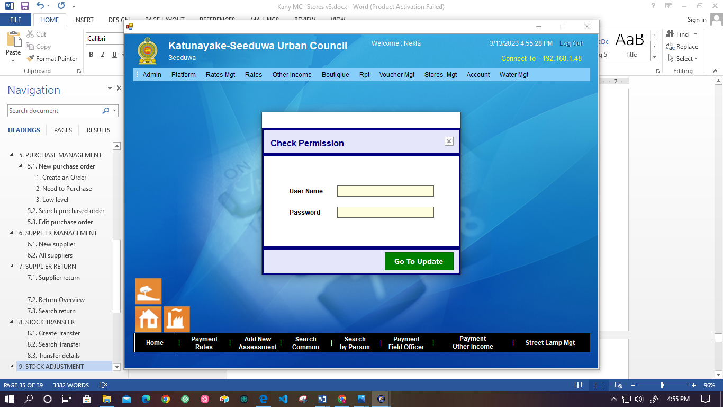

* The system facilitates the user to adjustment of stock.
* Authorized user can logging in to the system for the adjustment by entering the following details for the check permission.

|  |  |  |
| --- | --- | --- |
| **Attribute** | **Field Type** | **Comment** |
| User name | Text Field | Required |
| Password | Text Field | Required |

* After the system validates the user-entered details, the user can update the stock.

## **Create a stock adjustment**

* To create the stock adjustment user has to enter the following details.

|  |  |  |
| --- | --- | --- |
| **Attribute** | **Field Type** | **Comment** |
| Item code | Text Field | Required |
| Item Name | Text Field | Not Required |
| Quantity | Text Field | Required |
| Purchasing price | Text Field | Required |
| Reason | Drop –down (It already exist)  Else (***refer 9.1.1.)*** | Required |
| Description | Text Field | Required |
| Date | Calendar | Required |

* + 1. **Add reason for check Stock Adjustment**

|  |  |  |
| --- | --- | --- |
| **Attribute** | **Field Type** | **Comment** |
| Reason | Text Field | Required |
| Reason type | Drop-down | Required |

* After creating stock adjustment user can do save or cancel.
* Also, the user can view the details of items in the stock, and there is the option to print and save the details list.

## **Search stock adjustment**

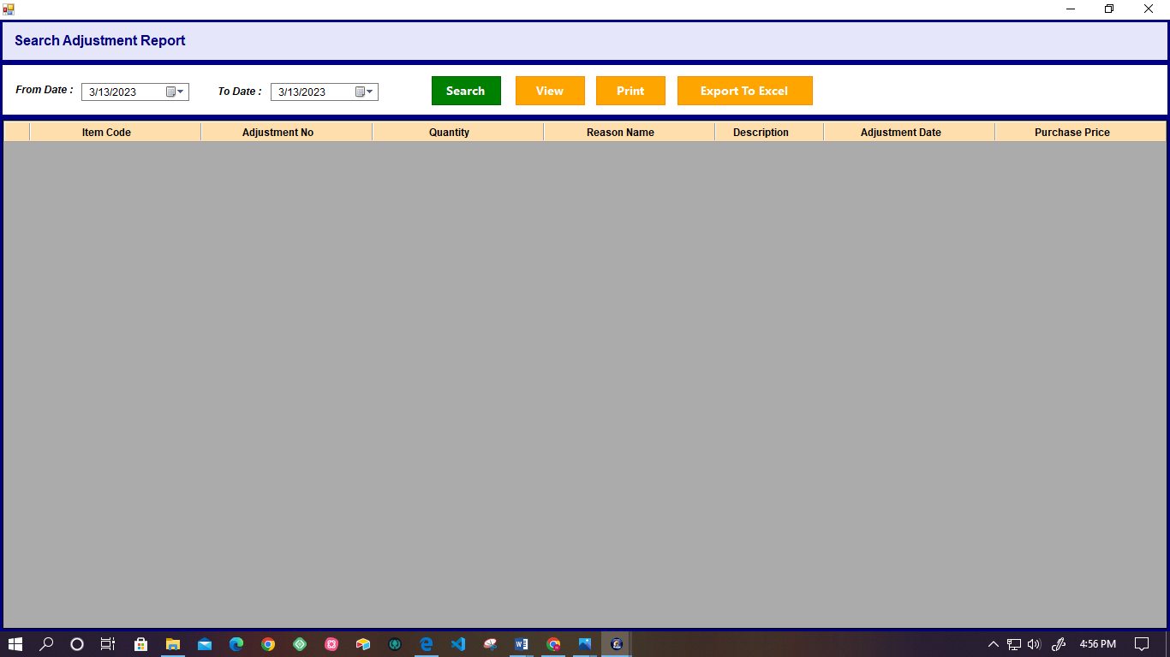

* System facilitates the user to get the adjustment report details by searching the particular date period.
* Following details are display by the system.
* Item Code
* Adjustment Number
* Quantity
* Reason Name
* Description
* Adjustment Date
* Purchase Price.
* Also user can View, Print details and Export details into the excel sheet.

# **STOCK REPORTS**

## **VIEW OPENING STOCK IN EACH YEAR**

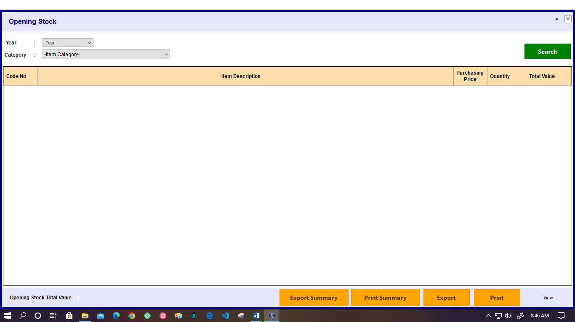

* System facilitates to user to get the list of details of opening stock in each year by selecting the year and category.
* Following details are displays the list of details.
* Code Number
* Item description
* Purchasing price
* Quantity
* Total value
* System automatically displays the Opening stock value total.
* There is an options of export and print the summary report.

## **VIEW RECEIVED STOCK BY CATEGORY**

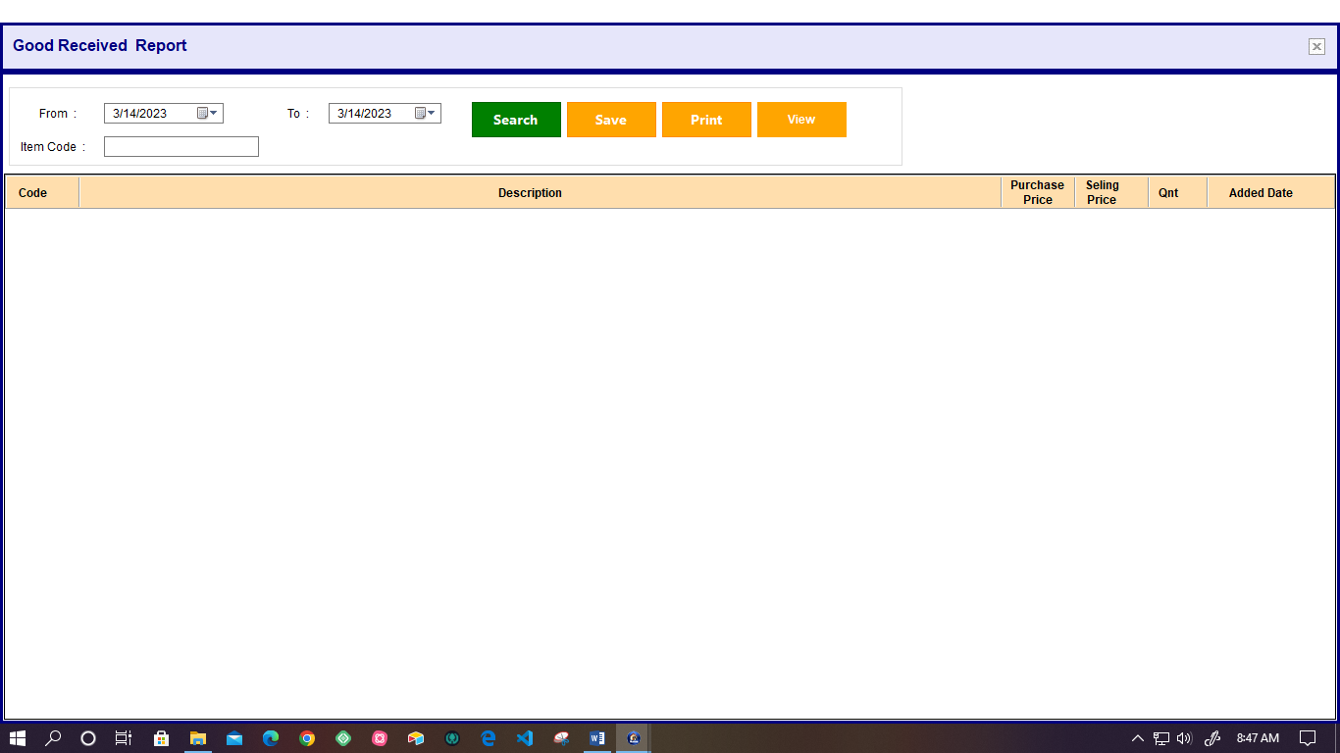

* System provide facility to user to get the report of added stock summary report by searching the time duration and category of the item.
* Following details display in the summary report.
* Code
* Description
* Quantity
* Units
* Purchas price
* Total
* Also user can view, Print, and Export the summary report.

## **STOCK TRANSFER REPORT**

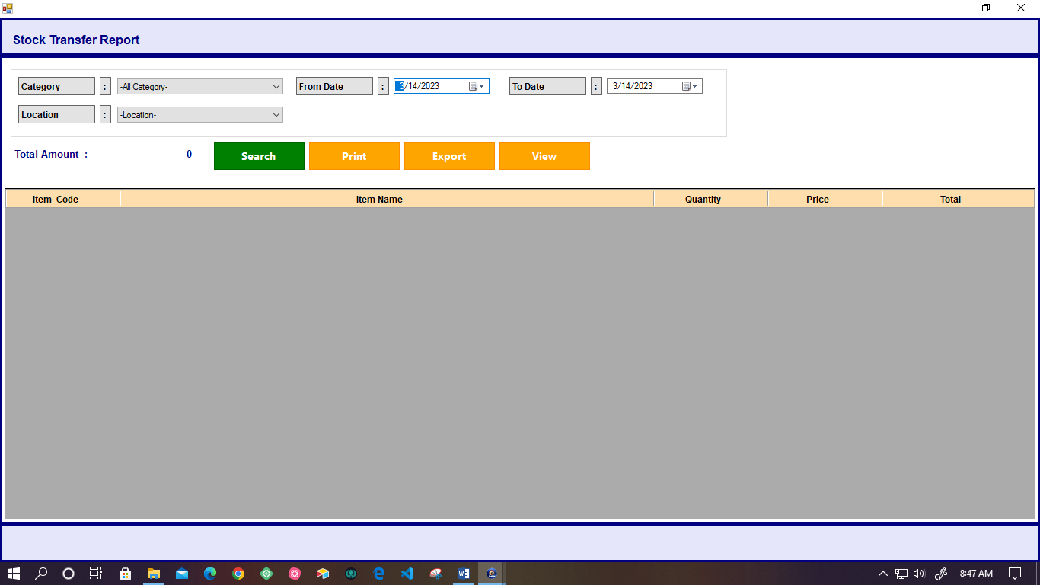

* System facilitates to get the stock transfer report searching by the following details.
* Category
* Location
* From date
* Two date
* Also automatically displays the total amount of the stock transfer.
* Following details are displays in the list of summary report.
* Item Code
* Item Name
* Quantity
* Price
* Total
* User can view, print and export the summary report.

## **SEARCH STOCK TRANSFER DETAILS REPORT**

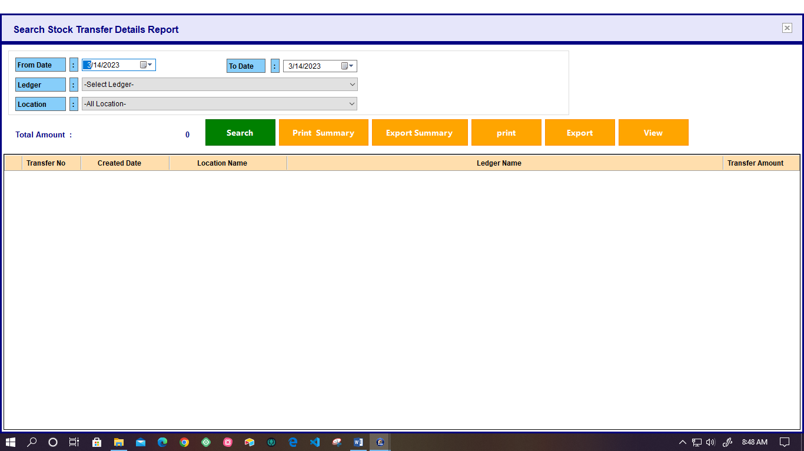

* This system facilitates to get the stock transfer details report by searching the time duration, Ledger and location.
* User can view the Total amount of the stock transfer.
* Also provide the facility of the export the summery report and print the summery report and, print, export and view the details.

## **GET THE STOCK TRANSFER SUMMARY REPORT – EXPENSES LEDGER WISE.**

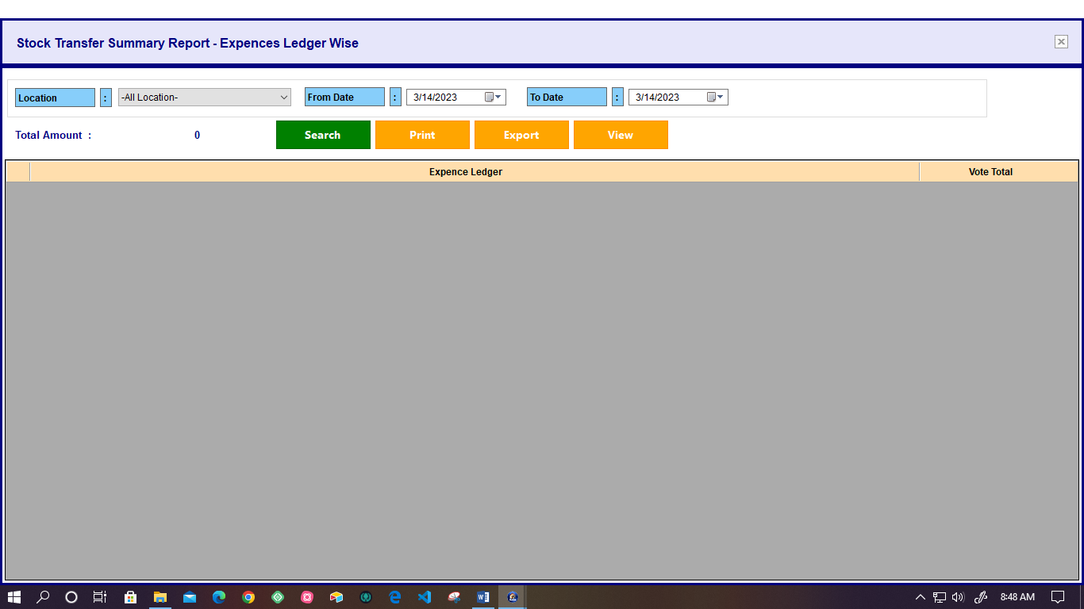

* User can get the stock transferred details by searching the Location, from date and to date.
* Also system automatically displays the Total amount.
* Following stock transfer details are displayed the expenses ledger wise.
* Expense Ledger
* Vote Total

## **BIN CARD**

### **View bin card**

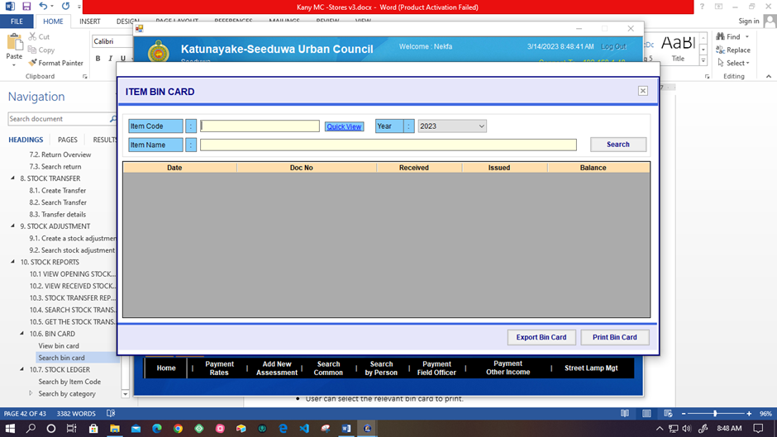

* System facilitates to get the Item Bin Card details in the each year by searching the Item code, Item Name.
* Following details are consist as the bin card details.
* Date
* Doc Number
* Received
* Issued
* Balance
* Also there are options of the Export bin card and Print bin card.

### **Search bin card**

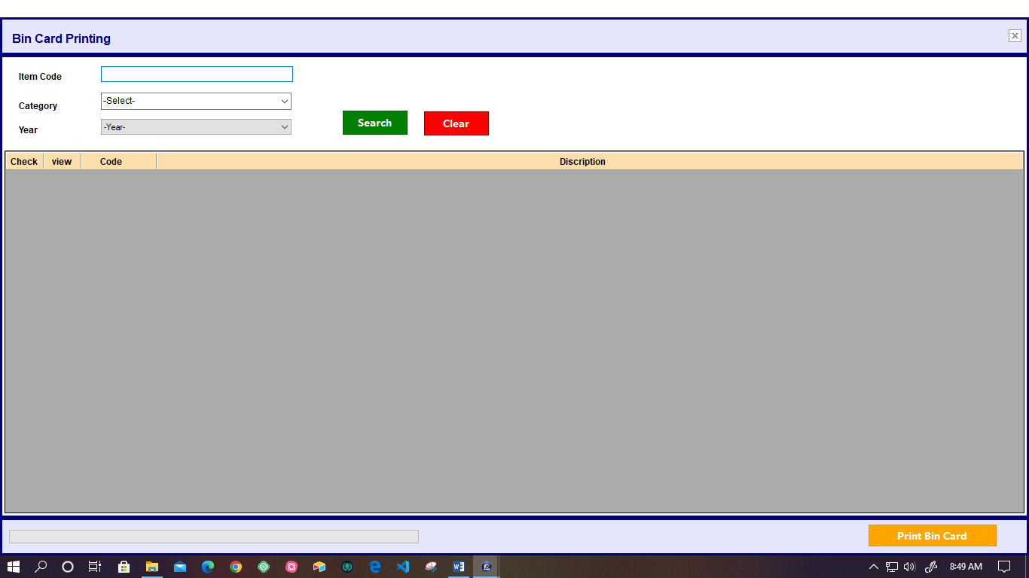

* To bin card print, User can search the item searching by the Item code, Category, Year. Also there is clear button.
* User can select the relevant bin card to print.

## **STOCK LEDGER**

### **Search by Item Code**

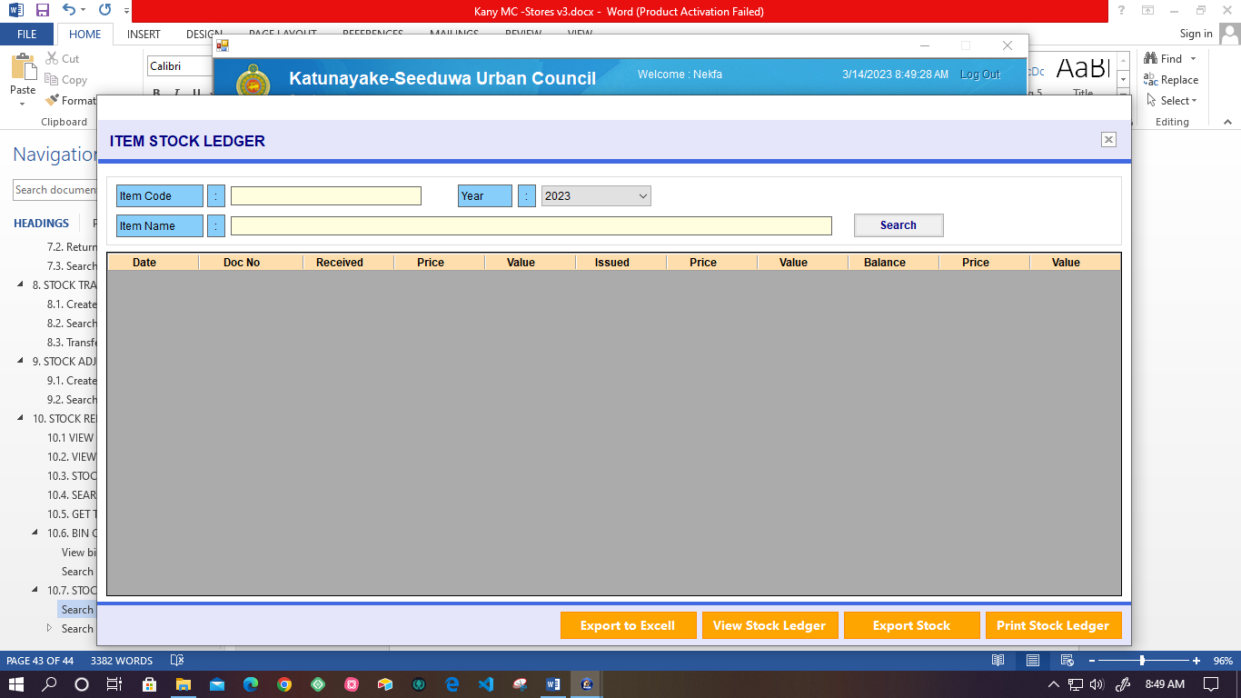

* System facilitates the get details of item stock ledger in each year by searching the item code.
* Following details are displayed for the stock ledger of received, issued, and balance.
* Date
* Doc Number
* Received
* Price
* Value
* Also details can export the excel sheet, View the Stock Ledger, Export Stock, print the stock ledger.

### **Search by category**

#### Item Wise

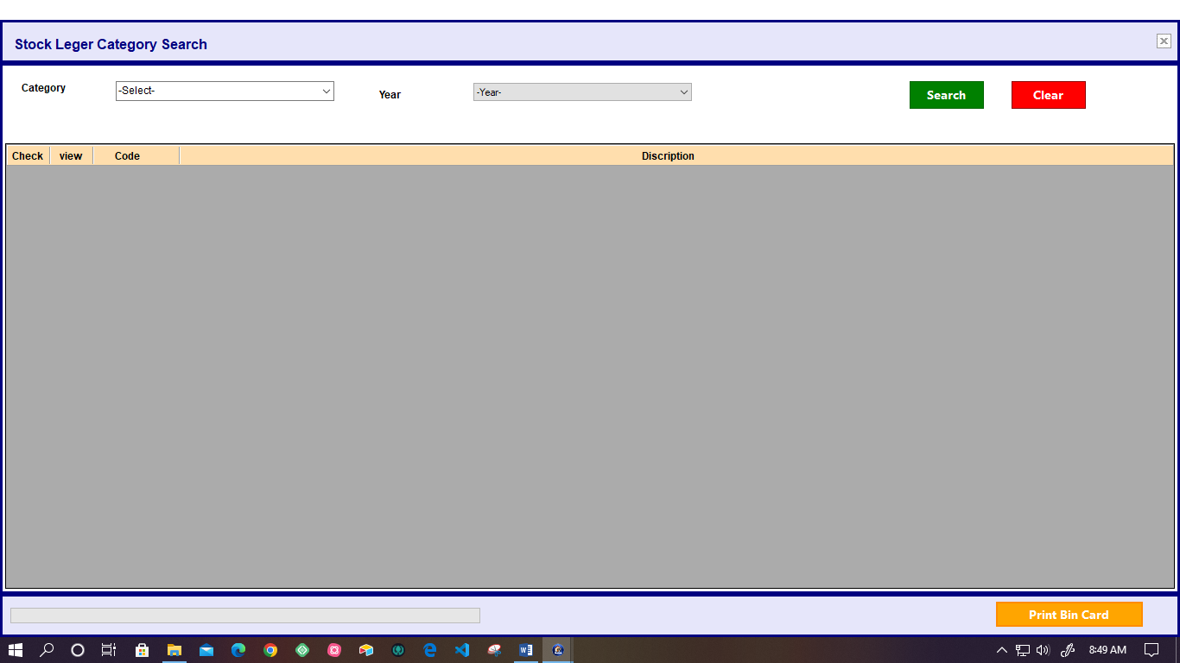

* Using this system user can get stock ledger details item wise by searching the item category and year.

#### All

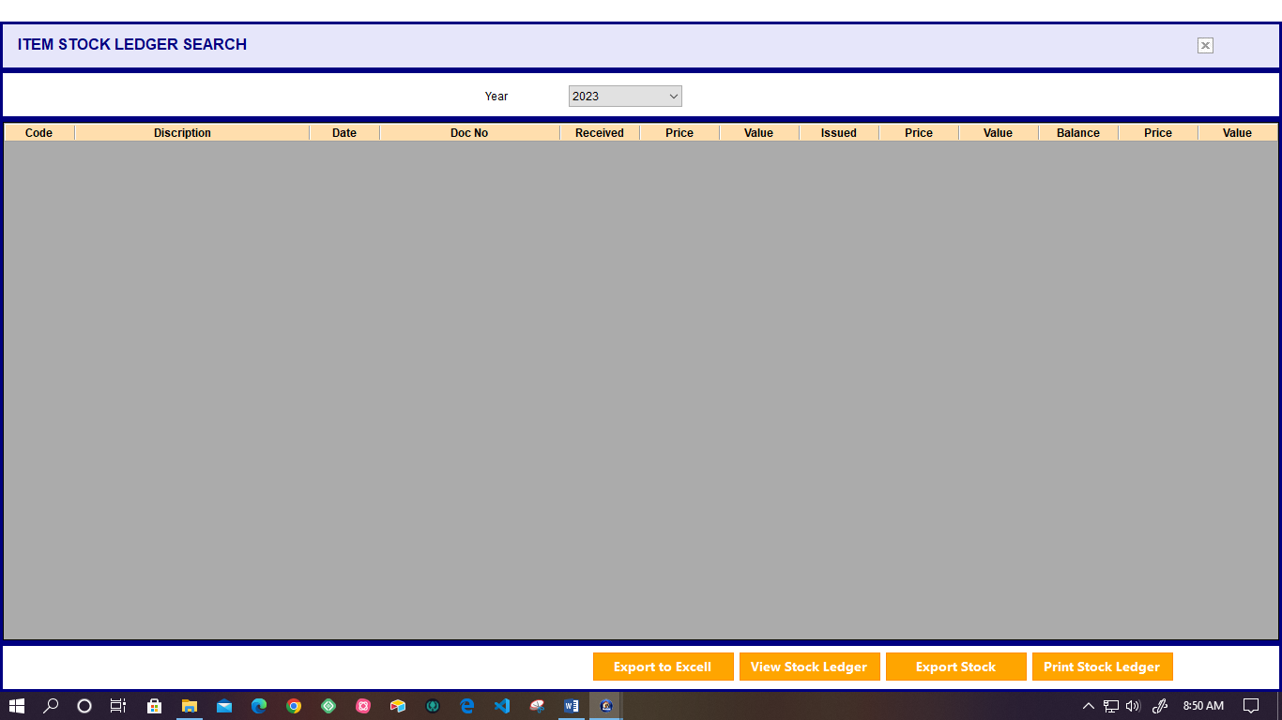

* User can search the item stock ledger all details by searching the Category Name and related year.